RJC POLICY rev.01
Nuovi Gioielli srl is a medium-sized company engaged in the processing of precious metals for its own brand and some well-known jewelry brands. The company is located in Mussolente (VI) in via Alessandro Volta 1 and employs about forty people, engaged in goldsmithing, from the fusion of the raw material to the creation of the finished product. Nuovi Gioielli srl is a member of the Responsible Jewelery Council (RJC). The RJC is an organization that sets standards to promote ethical behavior, human rights, social rights and environmental practices throughout the jewelry supply chain with diamonds, gold, silver, platinum metal groups and certain precious stones ( sapphires, emeralds and rubies).
RJC has developed a gold standard for the jewelry supply chain and credible mechanisms for verifying responsible business practices through third party audits. As RJC Certified Members, Nuovi Gioielli srl undertakes to manage its business in accordance with the RJC code of practice. It also undertakes to integrate ethical, human, social and environmental considerations into daily operations, business planning activities and decision-making processes. In the Sustainability Report that the company issues each year, the company performance is defined with regard to specific objectives that the company sets itself from year to year.
In particular, these principles can generally be summarized as follows:
- Respect for good business practices (absence of corruption)
- Absence of child labor
- Absence of forced labor
- Compliance with health and safety requirements
- Freedom of association
- Absence of discrimination
- Correct management of disciplinary practices in compliance with mandatory requirements and correct management of workers Fair and decent remuneration
- Working hours consistent with the requirements dictated by the applicable CCNL
- Respect for the environment and promotion of the reduction of consumption and good practices in the management of waste and non-reproducible resources
- Condemnation and rejection of any activity related to war crimes, violations of international humanitarian law, crimes against humanity or genocide
- Commitment not to give any direct or indirect support to armed groups, to fight corruption or bad practices in the gold, silver and diamonds and precious stones supply chain and the abuses associated with their extraction, transport and trade
- Commitment not to offer, promise or request bribes and oppose the solicitation of bribes, request to conceal, disguise the origin of gold or misrepresent taxes, duties, tariffs and royalties paid to governments for the purpose of mining, trading , handling, transport and export of gold
- Commitment to ensure that all private security activities and security measures in defense of assets comply with national laws while respecting the dignity of the worker.
In compliance with these requirements, the company declares to comply with the following regulations and conventions:
- To the voluntary standard RJC CoP- 2019
- To the RJC Voluntary Standard - Coc 2017
- To the Conventions of the International Labor Organization (ILO)
- To the United Nations Convention on the Rights of the Child
- To the Universal Declaration of Human Rights
- To the United Nations Convention on the Elimination of All Forms of Discrimination Against Women and All Forms of Racial Discrimination
- To the International Covenant on Civil and Political Rights and on Economic, Social and Cultural Rights.
- To all national and international laws on the subject, including Legislative Decree 81/2008 and subsequent amendments, relating to health and safety in the workplace and the European Regulation 679/2016 relating to the confidentiality and processing of personal data and Legislative Decree 152/2006 on environmental matters and subsequent amendments
- To the requirements of Legislative Decree 231/2001 on corporate administrative liability.
- To the OECD Guideline on due diligence for responsible supply chains of minerals from conflict-affected and high-risk areas.

General direction
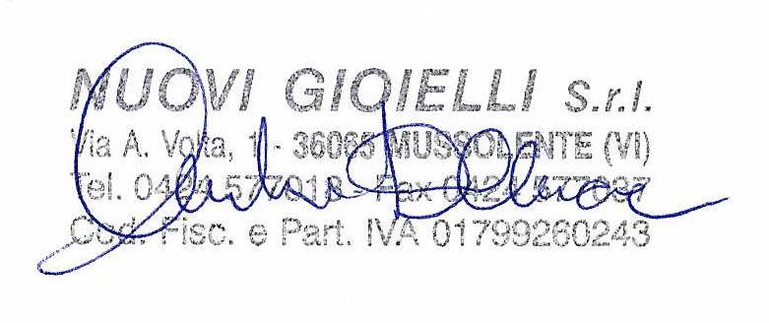
Mussolente , 26/04/2021

